`

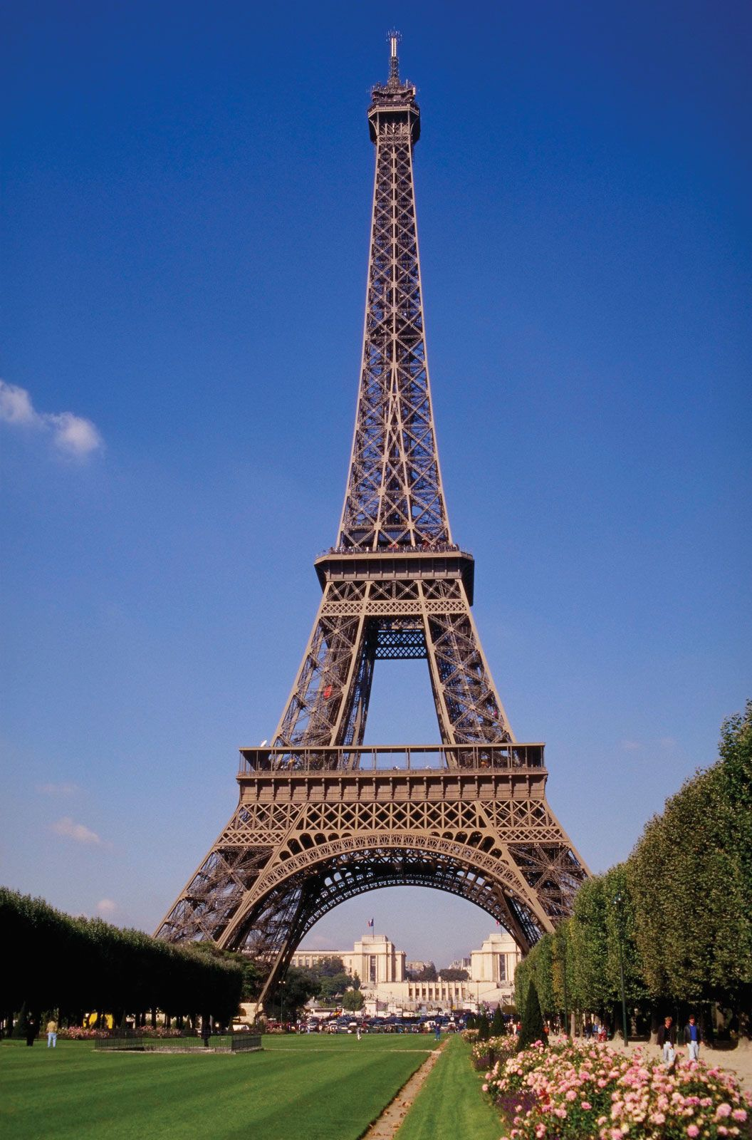



**Computing**

**Email**

This will be accessed through DBPrimary

**Coding**

Algorithm – a clear set of sequenced instructions given to make something happen.

Debugging – identifying and removing errors.

**E-safety**

* Don’t go online without adult permission.
* Tell and adult if something upsets you.
* Keep personal information and passwords secure.
* Be polite to other people online.
* Friends are real people you know.

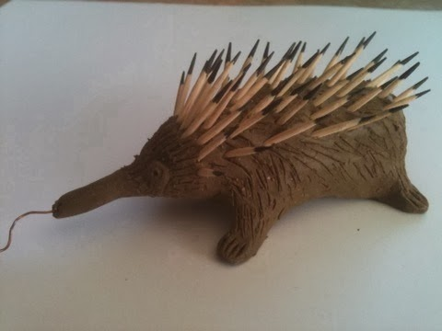

**Design and Technology: textiles**

**Types of stitch:** blanket stitch used for joining pieces, running stitch used for tacking, cross stitch used for decorating

**Embellish:** apply decoration

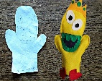

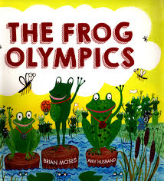

**Focus author: Brian Moses**



**Science – Plants**

Leaves use the light of the sun and water to make energy

Stems support the plant.

Roots anchor the plant in the soil and take up water.

Flowers attract insects to pollinate then. They are where the seeds form.

Evergreen: a plant that keeps its leaves in winter.

Deciduous: a plant that loses its leaves in winter

**The Human Body**

Skeleton: support the body and protect the organs

Heart: pumps blood round the body

Lungs: take in oxygen

Brain: controls essential organs, thoughts and memory

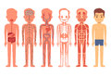

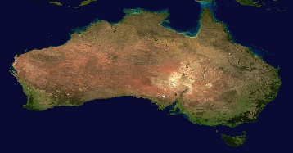 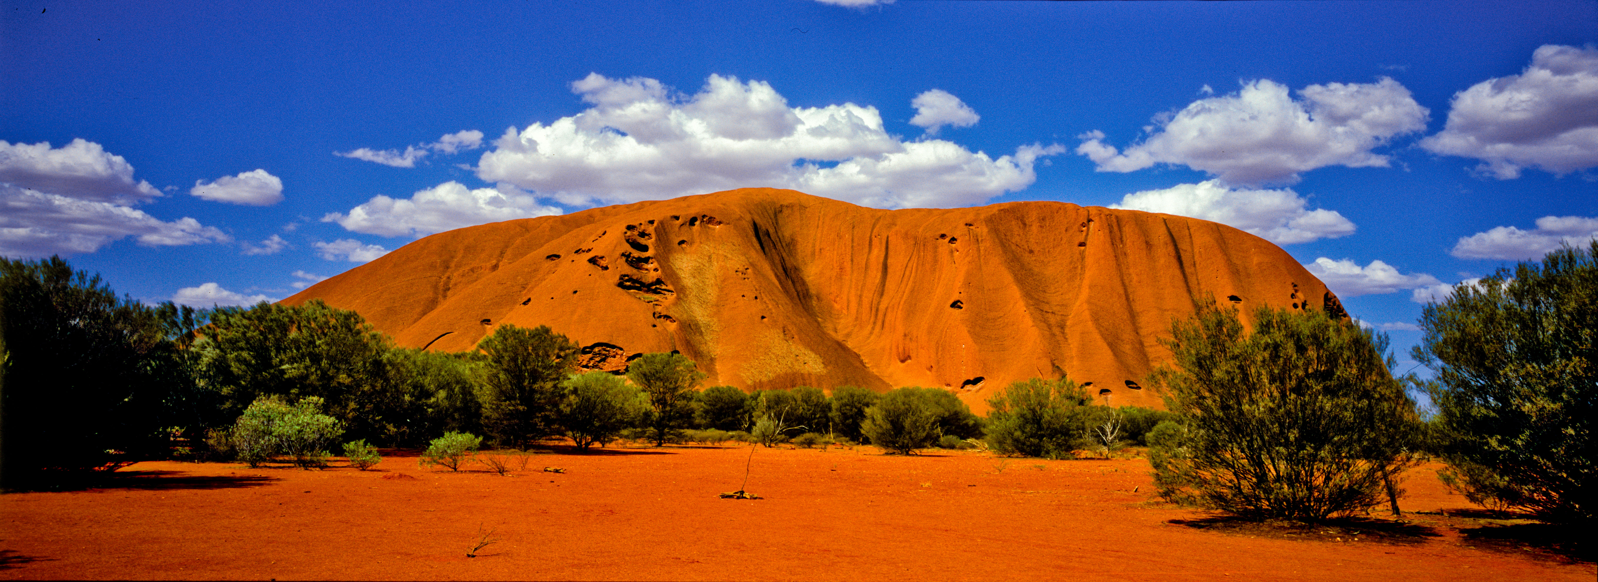 

**Geography – a contrasting locality: Australia**

**Capital:** Canberra

**Population:** over 25 million

**Area:** over 7,500,000 square kilometres, similar to USA

90% of Australians live near the coast

**Oceans:** It is surrounded by the Indian and Pacific Oceans

**Organisation:** It comprises 6 states and 2 territories**.**

**Geographical features:** Great Barrier Reef, Uluru, Sydney Harbour

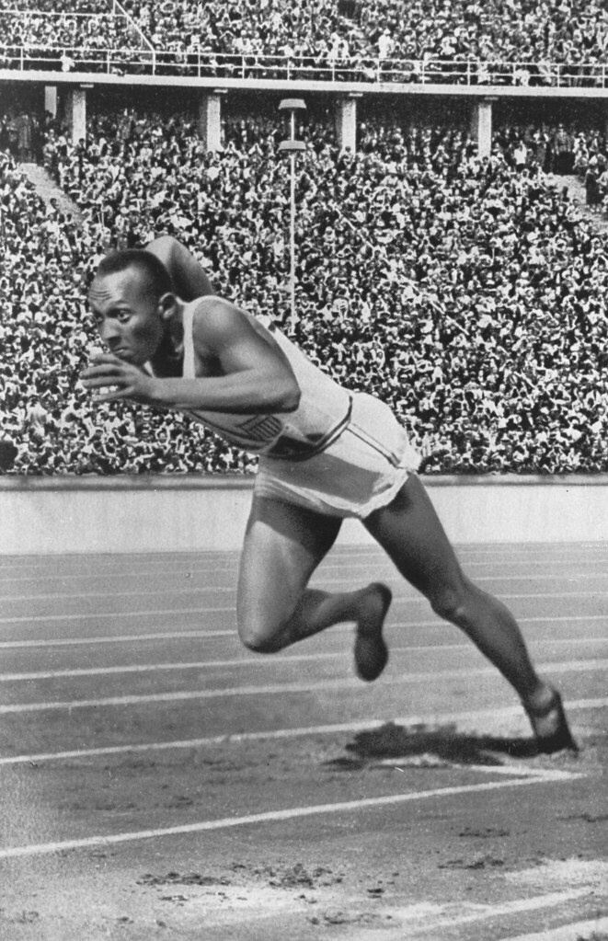

**History – A Prominent Person from the Past**

**Jesse Owens**

Jesse Owens lived 1913-1980, growing up through the **Roaring Twenties** and the **Great Depression**.

He was the youngest of 10 children.

His family moved from Alabama to Ohio as part of the **Great Migration** of African-Americans in search of a better life.

He equalled world records when he was in high school.

Jesse won 4 gold medals in the Berlin Olympics of 1936 (100m, 200m, long jump and 4x100m relay), annoying the ruling racist Nazi Party ruled by Adolf Hitler, which believed in white supremacy.

**Art: sculpture**

**Sculpture**: the act of making 3D art by shaping materials (by carving, moulding or assembling).

**Statue:** a figure of a person or animal.

**The Road to Paris**

**Knowledge Organiser - Year 1**