Electricity assessment-Year 2 Autumn term-2

Name………………………………………………………… Date……………………………………………………

Draw or write three items that use electricity

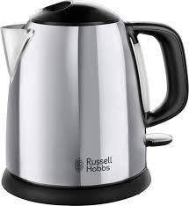
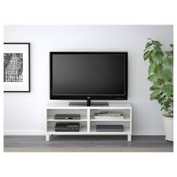
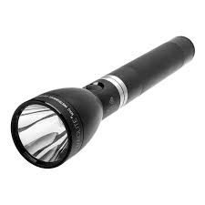
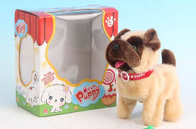
Tick the objects that use batteries only.

Draw a circuit diagram that would light up a bulb

How can you make the bulb brighter?
……………………………………………………………………………………………………………………………………………………
……………………………………………………………………………………………………………………………………………………

What would happen if you had two bulbs and one battery in one circuit?

……………………………………………………………………………………………………………………………………………………………

…………………………………………………………………………………………………………………………………………………………….

Can you think of three things you must remember to keep you safe when using electricity?

1………………………………………………………………………………………………………………………………………………………

2………………………………………………………………………………………………………………………………………………………

3………………………………………………………………………………………………………………………………………………………

Is there anything else that you have learnt about electricity this half term?

