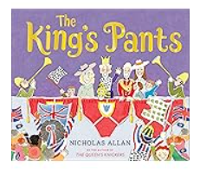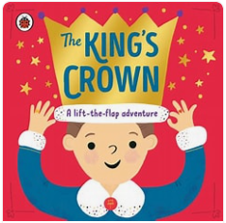

Personal, Social and Emotional Development

Core Values –

The Zones of Regulation - Consider the needs of others

Healthy Eating and the Importance of exercise

Team work

Transition to year 1

Communication and Language

Learning new vocabulary

Use talk to organise thinking

Explain why things might happen

Speak using correct tense

Retell stories in a sequence from memory

Looking at rhyme and alliteration

Summer Term 2025

Time Travellers – Kings and Queens

Physical Development

Gross Motor- co-ordination and balance, Throwing and catching

Fine Motor- Handwriting, using a range of tools including scissors

PE – Athletics, Sport’s Day

Expressive Art and Design

Making crowns

Painting portraits of kings and queens

Building 3d models of towers

Role play activities

Exploring sounds using musical instruments. Making instruments

Mathematics

White Rose Maths

Making teen numbers

Addition and Subtraction

Shape

Time and Measure

Number bonds

Exploring in the maths area

Understanding the World

Looking at our Royal family

Exploring kings and queens of the past

Looking at our family tree

Whole school trip to Layer Marney

Kings and queens around the world

Summer – changes of the season

EYFS Medium Term Plan

Summer 2025

Literacy

Focus author – Kes Grey

Focus book – The King’s Crown by Rose Cobden, The Kings Pants by Nicolas Allen

EWI (Early writing instruction)

Rocket phonics – consolidation of digraphs,

Writing sentences using finger space, capital letters, full stops