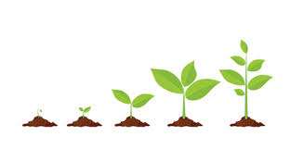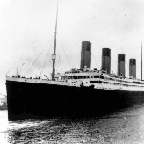;

**Science – Habitats and what plants need to grow.**

**A habitat is a place that an animal lives. It provides the animal with food, water and shelter.**

**There are many different sorts of habitats around the world.**

**Animals eat plants and other animals within their habitats making a food chain.**

**A food chain always starts with a producer. A producer is a plant because it can produce/make its own food.**

**Plants need water, warmth, food and sunlight for healthy growth. Most plants produce flowers which turn to fruit.**

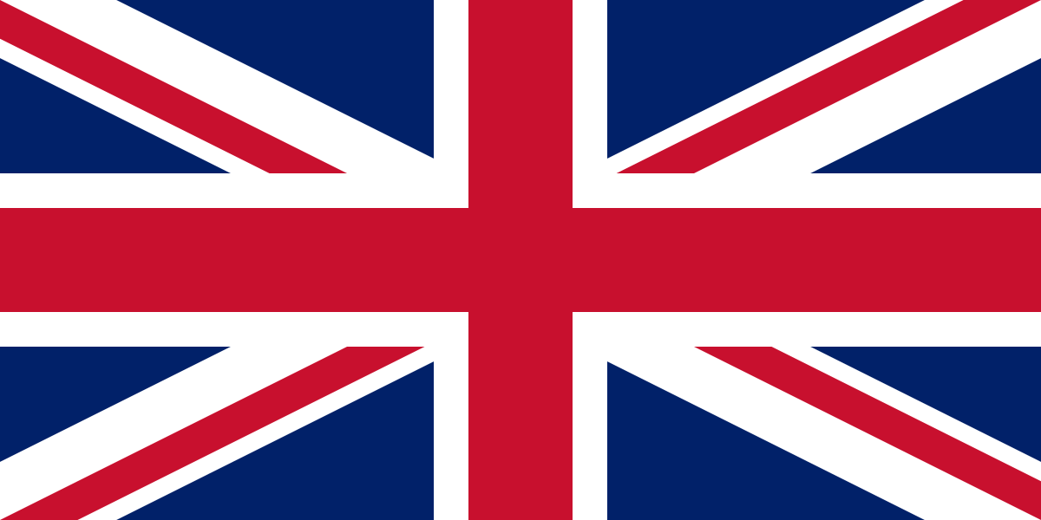

 **Computing- Using the internet and PowerPoint**

1. **Open PowerPoint.**
2. **Click file and then new presentation.**
3. **Click on design then chose.**
4. **Select your background.**
5. **Insert text and pictures.**

**This is the internet icon. We use google to search for things.**

**History – The RMS Titanic**

**The Titanic was a very large and very luxurious cruise ship that was built in 1912.**

**On the 10th April the Titanic set out on its maiden voyage (first journey) taking people from Southampton in England to New York in America.**

**The Titanic’s captain was called Edward John Smith and he had a crew of 900 people.**

**There were over 2200 people on board.**

**People travelled either in first class, second class or third class.**

**On the 14th April 1912 the Titanic hit an iceberg and tragically sunk.**

**There weren’t enough life boats on board the Titanic and many people sadly died when it sunk.**

**Geography – UK capitals and weather**

**The UK**

**The United Kingdom is made up of four countries (England, Scotland, Wales and Northern Ireland).**

**The capital city of England is London, the capital city of Scotland is Edinburgh, the capital city of Wales is Cardiff and the capital city of Northern Ireland is Belfast.**

**The official flag is the Union Jack.**

**The population (number of people living there) is around 64 million!**

**Currently the UK is ruled by King Charles III.**

**The currency (money) in the UK is the pound sterling.**

**Weather**

**The weather changes on a daily basis and is affected by the seasons and atmosphere.**

**Please watch some weather forecasts at home to become familiar with some of the symbols and vocabulary used. Here are some examples of the common symbols you may see:**

[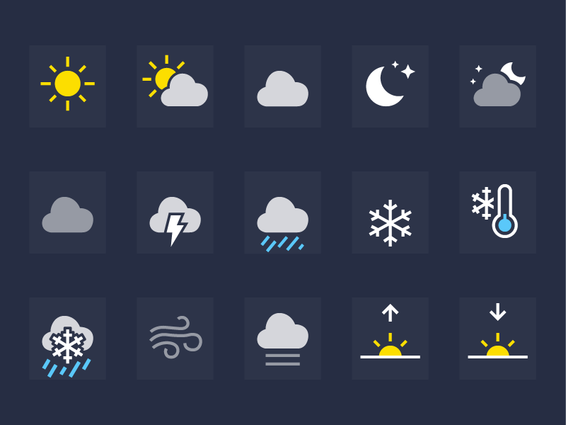](https://www.google.com/url?sa=i&url=https://metro.co.uk/2018/02/26/iphone-weather-symbols-mean-7343734/&psig=AOvVaw32_TumbiaKI1p_prjbjX8G&ust=1594221694093000&source=images&cd=vfe&ved=0CAIQjRxqFwoTCJDxzbK5u-oCFQAAAAAdAAAAABAI) **sunny** [](https://www.google.com/url?sa=i&url=https://metro.co.uk/2018/02/26/iphone-weather-symbols-mean-7343734/&psig=AOvVaw32_TumbiaKI1p_prjbjX8G&ust=1594221694093000&source=images&cd=vfe&ved=0CAIQjRxqFwoTCJDxzbK5u-oCFQAAAAAdAAAAABAI) **cloudy** [](https://www.google.com/url?sa=i&url=https://metro.co.uk/2018/02/26/iphone-weather-symbols-mean-7343734/&psig=AOvVaw32_TumbiaKI1p_prjbjX8G&ust=1594221694093000&source=images&cd=vfe&ved=0CAIQjRxqFwoTCJDxzbK5u-oCFQAAAAAdAAAAABAI) **lightning** [](https://www.google.com/url?sa=i&url=https://metro.co.uk/2018/02/26/iphone-weather-symbols-mean-7343734/&psig=AOvVaw32_TumbiaKI1p_prjbjX8G&ust=1594221694093000&source=images&cd=vfe&ved=0CAIQjRxqFwoTCJDxzbK5u-oCFQAAAAAdAAAAABAI) **snow**

[](https://www.google.com/url?sa=i&url=https://metro.co.uk/2018/02/26/iphone-weather-symbols-mean-7343734/&psig=AOvVaw32_TumbiaKI1p_prjbjX8G&ust=1594221694093000&source=images&cd=vfe&ved=0CAIQjRxqFwoTCJDxzbK5u-oCFQAAAAAdAAAAABAI) **icy conditions** [](https://www.google.com/url?sa=i&url=https://metro.co.uk/2018/02/26/iphone-weather-symbols-mean-7343734/&psig=AOvVaw32_TumbiaKI1p_prjbjX8G&ust=1594221694093000&source=images&cd=vfe&ved=0CAIQjRxqFwoTCJDxzbK5u-oCFQAAAAAdAAAAABAI) **strong winds** [](https://www.google.com/url?sa=i&url=https://metro.co.uk/2018/02/26/iphone-weather-symbols-mean-7343734/&psig=AOvVaw32_TumbiaKI1p_prjbjX8G&ust=1594221694093000&source=images&cd=vfe&ved=0CAIQjRxqFwoTCJDxzbK5u-oCFQAAAAAdAAAAABAI) **sleet**

**A Drop in the Ocean Knowledge Organiser**

**Year 2 – Spring Term**