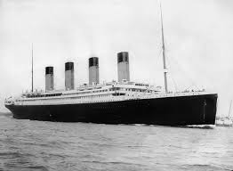
Can I research and record some facts about the Titanic?

