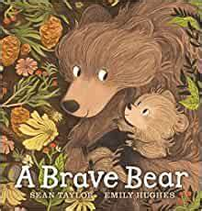

Personal, Social and Emotional Development

Settling into school life

Deciding the class rules together

Introduce the Zones of Regulation

My family

My favourite things to do

Learn how to use resources within the classroom environments (indoors/outdoors)

Develop independent hygiene skills

Making new friends

Physical Development

Gross Motor- spatial awareness, use of outdoor area and PE in the hall, Adventure playground

Fine Motor- Play dough, pencil control activities, threading beads.

Equipment safety rules

Communication and Language

Circle time – how to be a good friend, my favourite things, all about me

Listening skills, role play area. Enjoying stories, talking about the characters, retelling the story

Introduce new vocabulary

Sharing All About Me books

Introduce the concept of talk partners

(Baseline assessments)

Autumn

Bears, bears everywhere!

Expressive Art and Design

Draw a self-portrait

Singing familiar songs

Role play, Christmas play

Painting bears, Painting scenes

Clay bears

Mathematics

White Rose Maths

Counting and comparing amounts

Exploring pattern and shape

Match and sort objects

Compare size

Subitising

Exploring in the maths area

EYFS Medium Term Plan

2024/5

Understanding the World

Becoming familiar with the school surroundings.

Introduce The Everywhere Bear to go home.

Harvest festival, Sukkot, Diwali, Christmas

Seasons – Autumn and Winter

Literacy

Focus author – Jez Alborough

Focus books – A Brave Bear, The Everywhere Bear

Writing our names, developing our pencil grip and pencil control

Rocket phonics - Learning initial sounds

Blending and segmenting