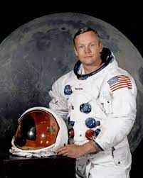
Neil Armstrong
- Born – 5th August 1930
- Died – 25th August 2012
- Neil Armstrong was a famous American astronaut and he was the first person to walk on the moon.
- America was in a space race with Russia. They both wanted to be the first to land on the moon!
- The American team landed on the moon on 20th July 1969.
- Neil Armstrong’s teammates were called Buzz Aldrin and Michael Collins.
- Apollo 11 was the name of their spacecraft.
- The team placed the American flag on the moon when they landed and it is still there today!
- When Armstrong landed he made this very famous speech-
‘That’s one small step for man, one giant leap for mankind.’
- The president of America at the time was a man called Richard Nixon.

