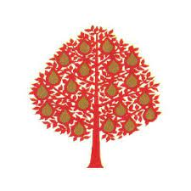

Foundation Stage High Frequency Words
Spelling Badge Award
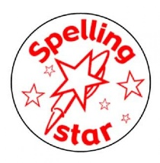
up | me
of | like
dog | going
big | she
see | they
at | away
yes | play
am | for
cat | a
her | he
come | all
day | to
look | be
are | into
this

