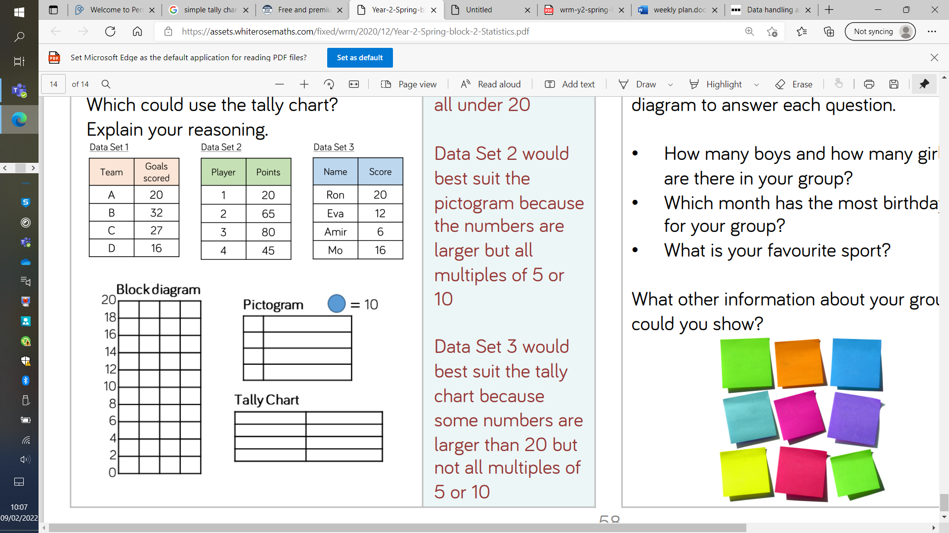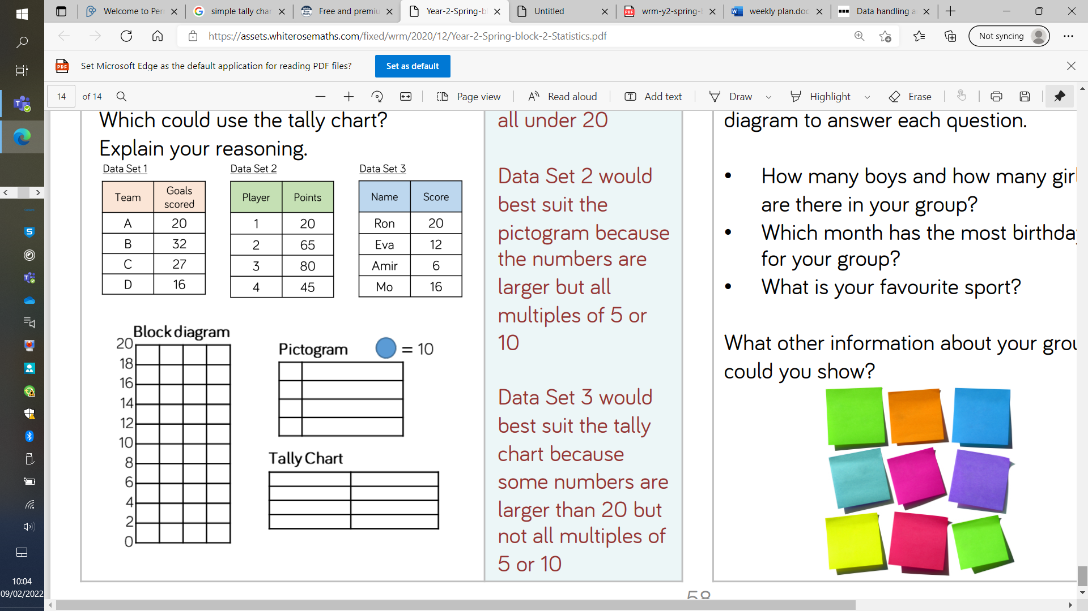 

Can you draw this data on the bar chart?

Can you draw this data on the bar chart?

**Tuesday’s Challenge – Block Diagram with scales of 2**

**Tuesday’s Challenge – Block Diagram with scales of 2**